Genetic Rescue Through Corridors - A Case Study of Habitat Fragmentation in the Hangul (Cervus Hanglu Hanglu) in Kashmir

Pranjel
Master's student of Ecology and Environmental Changes
Bielefeld University, Germany

Abstract

The Kashmir stag, is an endemic and critically endangered deer species found primarily in Dachigam Forest of the Kashmir, with an altitude preference ranging from 1,600 to 4,000 meters. This herbivorous species belonging to the red deer family is facing imminent threat of population loss and extinction. The development projects led by the humans accelerated the process of habitat fragmentation, leaving animals isolated in fragmented regions and contributing to inbreeding depression, which has led to an overall decline in the population of animals like hangul of Kashmir. These days such issues are worldwide and there is an urgent need to address them. To address these issues, there is an urgent need to map and restore natural corridors to facilitate gene flow and maintain heterozygosity. A new non-invasive landscape-level conservation plan can be laid out by identifying and reconnecting long-lost potential corridors using technologies like GIS and camera traps, reassessing the current levels of inbreeding and their population structure by using the genetic data. This approach will not only help safeguard the Kashmir stag and ensure the survival of its unique genetic lineage but will also contribute to future planning and conservation actions for other species also. This study will also promote the overall equilibria of the ecosystem and highlight of importance of nature provided conservation options.

Graphical abstract

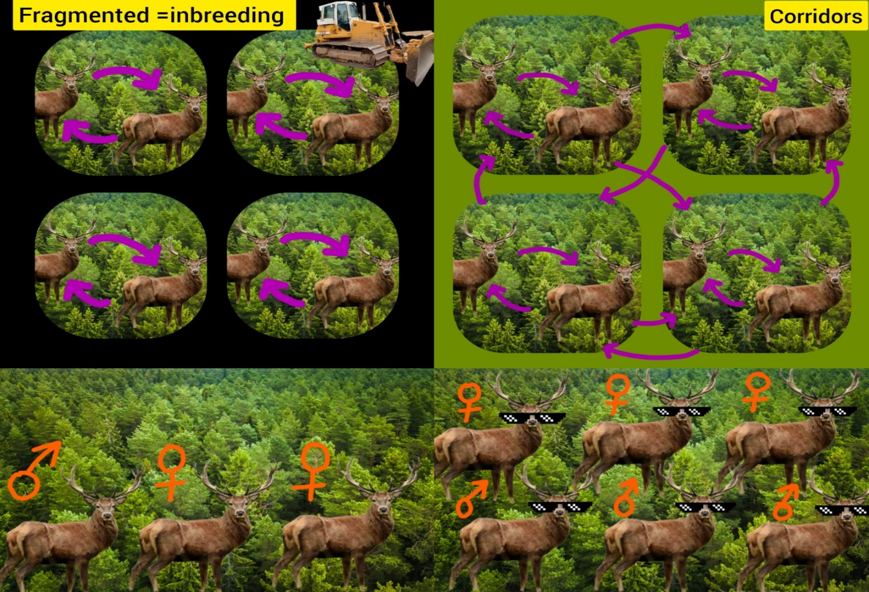

State of the Art

The rapid increase in urbanization has fragmented the natural habitats of animals into smaller and isolated patches, which has profoundly impacted their ecological interactions, reproductive behaviour, foraging patterns, and survival abilities (Haddad et al., 2015; Fischer & Lindenmayer, 2007). The accelerated process of urban expansion in Kashmir, along with human activities such as road construction, livestock grazing, and firewood collection, has significantly impacted the dynamics of local flora and fauna (Qureshi et al., 2012). Thus, the escalation in anthropogenic pressure is confining the wildlife into small isolated patches by destroying their habitats and disrupting the equilibrium of the ecosystem.

Due to the constant increase in habitat fragmentation and human-led activities, animal movement and dispersal have been restricted to smaller habitat patches (Sawyer et al.2009). Consequently, limited mate availability forces animals to breed with close relatives, resulting in elevated levels of inbreeding within the species (Frankham et al., 2010). Such inbreeding increases the risk of genetic disorders and reduces the overall fitness. Mating between genetically related individuals over successive generations leads to a decrease in heterozygosity, thereby causing genetic erosion (Keller & Waller, 2002). Since the adaptability potential is reduced, consequentially, the overall population suffers, and the health of the offspring is also compromised.

In almost every species, the males suffer greater effects of inbreeding depression. Their reproductive health and lifespan is affected, thereby skewing the overall sex ratio (Hedrick & Kalinowski, 2000). If continued, inbreeding depression might push the species towards extinction. A lot of research has drawn correlation between how inbreeding leads to overall decline in the population of any species (Saccheri et al., 1998). Therefore, for the survival of a species, it is very crucial to maintain diversity in the genetic pool.

Identifying and restoring the potential and abandoned natural corridors is crucial to maintain the diversity in the genetic pool and to assist the flow of genes between the fragmented patches (Beier & Noss, 1998). These corridors enable the animals to access the suitable breeding ground, therefore help the animals to re-establish the genetic diversity, thereby declining the risks that come with the inbreeding depression. Previous researches done on the Indian elephants, Indian tiger, and Florida-based panther have shown positive results in their population when the natural corridors were re-introduced (Dutta et al., 2015; Maehr, 1997). Hence, the effective corridor designing will take into consideration movement patterns, habitat preference, vegetation on the trail, and minimum chances of predator and human conflicts. Thus, these natural corridors act as a strategic conservatory tool by promoting interbreeding and species dispersal.

A study was conducted on the Kashmir stag (Cervus hanglu hanglu), a herbivore subspecies of red deer endemic to Kashmir, characterized by its 16-point antlers (Qureshi et al., 2012). They thrive and survive as matriarchal groups, with males joining them only during the breeding season. It is also found that this species has now been classified as endangered due to habitat fragmentation and resulting inbreeding (IUCN, 2021). Many recent studies showed the presence of 237 animals, with a predominantly female population, pointing towards the urgent need for conservation interventions (Department of Wildlife Protection,Jammu and Kashmir, 2019Hangul population census report. Jammu and Kashmir Government).

Studies using non-invasive genetic sampling helped in calculating the population and developing genetic fingerprints using microsatellite markers, which clearly revealed signs of low heterozygosity, reduced allelic diversity, and greater similarity in the genetic pool, indicating past genetic bottlenecks (Mukesh et al., 2010). An urgent need for genetic rescue was highlighted by previous research, although limited attention was given to the role of natural corridors and how they could help in enhancing genetic health, maintaining diversity, and restoring balanced gender ratios in future populations. Intensive research must be conducted on destroyed and abandoned natural corridors that were once heavily used, so they can be identified and restored to prevent the extinction of the species.

While previous research has emphasised more on assessing their population, genetic health, and mapping down of their family trees, limited attention has been given to the role of natural corridors in improving the genetic picture of a species. Thus, conservation plans coupled with the restoration and establishing new ecological corridors

should be the priority, since captive breeding and ex-situ breeding alone cannot turn the tables around. But a long-term natural and sustainable solution is required to prevent the extinction of the Kashmir stag and to maintain the ecological integrity. This research will help in validating the success of natural corridors in bringing back a species from the brink of extinction and thus in future will help in resolving the issue with any other species with the readymade blueprint.

Project objectives

- To calculate the current population size and gender ratio of the Kashmir stag.

- To assess the genetic diversity among the surviving member of the species

- To study the level of inbreeding within the population.

- To assess presence of any active corridors and current habitat connectivity between fragmented habitat segments.

- To identify and study the potential natural corridors that could restore gene flow between populations.

- To recommend landscape modification or protection strategies based on corridor suitability.

Project hypothesis

If all the potential , destroyed and abandoned natural corridors will be mapped , reconnected and made accessible to the hangul species while fulfilling their conditions to start exploring them . Then its going to act as a bridge that will facilitate the flow of genes across the various fragmented and isolated patches. As a result, the overall population will rise, male calf health will improve , the skewed gender ratio will get balanced and the genetic disparity will also get stabilized. Thus the instrumentation of the ecological corridors will supress the negative impacts of the inbreeding and support the overall growth of the species.

Predictions

- Animals connected through restored natural corridors will show greater genetic variety and improved calf health.

- Isolated populations will continue to suffer from inbreeding depression.

- Landscape connectivity indices will correlate positively with genetic exchange markers.

- The skewed sex ratio will get balanced.

- The risk of Human and other predator conflict will minimize

- They will be freely exploring and establishing new breeding and foraging grounds.

Methods

Study Area

Dachigam National Park, which is situated in Srinagar, a significant city in the state of Jammu and Kashmir , will be the site of the proposed study. Dachigam National Park occupies an area of approximately 144 square kilometres and is situated in the Western Himalayan Zabarwan range. Elevation of the park ranges between 1600 to 4200 meters above sea level. The park is known as the major habitat of the endangered Kashmir stag and is home to more than 364 plant species. However, the study area has been greatly impacted by rapid urban expansion, as the built-up area has grown by 325 percent in recent years.

Study Species

The Kashmir stag, locally known as the Hungul, is the study species for proposed proposal. It is a herbivorous species and found in the Dachigam forest. The Kashmir stag prefers deciduous forest and moves up to 4000 meters of altitude in the summer and back to altitudes of 1600 to 2400 meters during the winter. It thrives in matriarchal groups of up to 18 female members and males joining during the breeding season, which is often indicated by their unique rutting calls. However, because of habitat fragmentation, the species is experiencing an increase in breeding depression, with only about 237 individuals remaining, with more females and only about 85 males. The population currently has an estimated breeding coefficient of 0.38.

Data Collection

1. Population Survey
- By conducting non-invasive genetic sampling (hair, faeces) to identify the sex and calculate the population individuals and species.
- Estimate total population size and gender ratio using genetic markers.
- Deploy camera traps ,GIS mapping to monitor movement and validate population counts and also to take into consideration presence of any active corridors being taken up by these animals
2. Genetic Analysis
- Analyse collected DNA samples to calculate inbreeding coefficients.
- Assess genetic diversity levels within and between fragmented groups.
- Identify segment-specific genetic patterns using microsatellite markers.
3. Corridor Identification and Modelling
- Use GIS mapping and remote sensing to model, identify and create a digital layout of the existing natural corridors currently in use and identifying other potential corridors by doing field survey and with the help of the local communities
- Model potential corridor paths linking fragmented habitats with each other and with the rest of the forest .
- Assess corridor suitability based on landscape features, vegetation, and closeness to the current breeding grounds.
4. Future Population Modelling
- Predict future population growth trends under different scenarios that is with and without corridor restoration) .
- Modelling the impacts of gene flow restoration using population viability analysis (PVA) techniques.

5 Timeline and Ethics

- Field activities - during the breeding season (winter months), with peak animal movement and detection
- Strictly practising non-invasive sampling protocols to minimize disturbance to wildlife
- Required permissions and approvals will be obtained from relevant wildlife authorities before fieldwork.
- No harm to flora, fauna, or the ecological integrity of the Dachigam forest ecosystem will happen during surveys.

Budget

Budget item | Details | Estimated cost-euros
Field equipment and sampling supplies | Gloves ,forceps and storage and sampling kits for non invasive genetic analysis | 800
Camera traps | Motion triggered camera traps , batteries , memory cards | 2500
DNA extraction and genetic analysis | Lab reagents, primers, technician fee, Laboratory costs for DNA extraction, amplification, and microsatellite analysis. | 2500
Gis and remote sensing software access | ArcGIS license or subscription if not provided by the institute | 800
Transport and field logistics | Vehicle rental and fuel costs during the entire field survey | 500
Accommodation and food | Stay and meals during fieldwork | 400
Permits and permissions | Wildlife research permits and administrative fees | 100
Modelling software and expert | Vortex-free software  Modelling expert | 300
Contingency fund |  | 300
total |  | 8200

Highlights

- Highlight 1:
Urbanization has accelerated habitat fragmentation in Kashmir, leading to isolated populations, restricted mate choice, and a massive increase in the inbreeding depression among Kashmir stag populations.

- Highlight 2:
Prolonged inbreeding has negatively impacted genetic diversity, skewed the gender ratios, reduced calf health, and particularly compromised male fitness, pushing the species towards extinction.

- Highlight 3:
Restoration and identification of natural corridors can significantly promote gene flow, enhance heterozygosity, improve genetic health, and ensure the long-term survival and recovery of the Kashmir stag.

Summary

The Kashmir stag is one of the most endangered and rare red deer species in India. The human-led urban expansion and habitat fragmentation are rapidly sweeping down its population by dividing it into fragments and leaving no variety for mating, which leads to inbreeding depression. This results in an overall decline in the population, with major blows falling on the males. Thus, there is an urgent need to carry out research to identify and restore natural corridors so that the animals can access better and more diverse mating opportunities, thereby giving birth to a healthier population, and freeing themselves from the claws of inbreeding depression and imbalanced gender ratios. This can help save the species from extinction, not only because it is rare and the state animal, but also because it holds a unique genetic lineage. Therefore, we must aim to save it through the optimistically designing and executing the future conservation plans.

References

Beier, P., & Noss, R. F. (1998). Do habitat corridors provide connectivity? Conservation Biology, 12(6), 1241–1252.
https://doi.org/10.1111/j.1523-1739.1998.98036.x

Department of Wildlife Protection, Jammu & Kashmir. (2019). Hangul (Cervus hanglu hanglu) population census report. Jammu & Kashmir Government.

Dutta, T., Sharma, S., McRae, B. H., Roy, P. S., & DeFries, R. (2015). Connecting the dots: Mapping habitat connectivity for tigers in central India. Regional Environmental Change, 15(1), 41–52.
https://link.springer.com/article/10.1007/s10113-015-0877-z

Fischer, J., & Lindenmayer, D. B. (2007). Landscape modification and habitat fragmentation: A synthesis. Global Ecology and Biogeography, 16(3), 265–280. https://doi.org/10.1111/j.1466-8238.2007.00287.x

Frankham, R., Ballou, J. D., & Briscoe, D. A. (2010). Introduction to conservation genetics (2nd ed.). Cambridge University Press.

Haddad, N. M., Brudvig, L. A., Clobert, J., Davies, K. F., Gonzalez, A., Holt, R. D., ... & Townshend, J. R. (2015). Habitat fragmentation and its lasting impact on Earth’s ecosystems. Science Advances, 1(2), e1500052. https://doi.org/10.1126/sciadv.1500052

Hedrick, P. W., & Kalinowski, S. T. (2000). Inbreeding depression in conservation biology. Annual Review of Ecology and Systematics, 31(1), 139–162. https://doi.org/10.1146/annurev.ecolsys.31.1.139

IUCN. (2021). Cervus hanglu ssp. hanglu. The IUCN Red List of Threatened Species 2021. https://www.iucnredlist.org/species/5593/22161433

Keller, L. F., & Waller, D. M. (2002). Inbreeding effects in wild populations. Trends in Ecology & Evolution, 17(5), 230–241. https://doi.org/10.1016/S0169-5347(02)02489-8

Maehr, D. S. (1997). The Florida panther: Life and death of a vanishing carnivore. Island Press.
Qureshi, Q., Sathyakumar, S., & Rawat, G. S. (2012). Ecology and conservation of Hangul in Dachigam National Park, Jammu & Kashmir. Wildlife Institute of India Technical Report.

Thakur, M. (2015). Species identification and molecular sexing from feces of Kashmir stag (Cervus elaphus hanglu). Conservation Genetics Resources. https://doi.org/10.1007/S12686-015-0475-X

Saccheri, I., Kuussaari, M., Kankare, M., Vikman, P., Fortelius, W., & Hanski, I. (1998). Inbreeding and extinction in a butterfly metapopulation. Nature, 392(6675), 491–494. https://doi.org/10.1038/33136

Sawyer, H., Kauffman, M. J., Nielson, R. M., & Horne, J. S. (2009). Identifying and prioritizing ungulate migration routes for landscape-level conservation. Ecological Applications, 19(8), 2016–2025. https://doi.org/10.1890/08-2034.1

